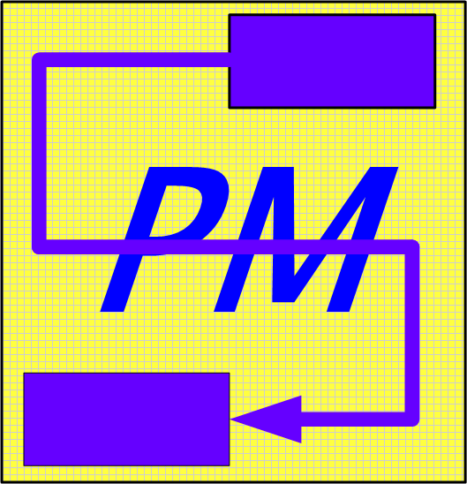 | Start to Finish PM, Inc.

MS Project Fundamentals for Project Managers (2 Day)

- Project Management Concepts
  - PM Background and Need for Project Managers
  - The 5 PM Processes
    - Project Initiation
    - Project Planning
    - Project Plan Execution
    - Project Controlling Processes
    - Project Closure
  - Applying Project Management Concepts to MS Project

- MS Project Essentials
  - Getting Started With Microsoft Project
    - Exploring the Microsoft Project Window
    - Identifying the Toolbars
  - Working with Project Files
    - Open an Existing Project File
    - Entering Project Information
    - Changing Default Settings
  - Identify View Elements
    - Gantt Chart
    - Resource Sheet
- Creating a Project
  - Creating a New Project File
    - Schedule from Start Date or Finish Date
  - Defining Tasks
    - Identify Task Characteristics
    - Identify Methods for Determining and Entering Tasks
  - Entering Tasks and Durations
    - Moving and Copying Tasks
    - Inserting and Deleting Tasks
    - Entering a Task as a Milestone
- Creating the Schedule

Organizing the Schedule
    - Creating Summary Tasks
      - Promoting Tasks
      - Demoting Tasks
    - Collapsing and Expanding Outlines

Start to Finish PM, Inc.

  - Creating the Schedule
    - Defining Task Dependencies
    - Linking and Unlinking Tasks
    - Modifying Task Dependencies
    - Creating Leads and Lags
    - Assigning Constraints
    - Identifying the Critical Path
- Assigning Project Resources
  - Defining Resource Needs
    - Creating a Resource List
      - Setting Maximum Units
    - Assigning Resources to Tasks
    - Removing Resources from Tasks
- Assigning Costs to Tasks and Resources
  - Entering Cost Information
    - Assigning Rates to Resources
    - Assigning Fixed Costs to Tasks
  - Viewing Project Costs
- Working With Calendars
  - Changing the Project Calendar
    - Setting Working and Non-Working Days
    - Changing the Work Week and Working Hours
  - Using Base Calendars
    - Creating a New Base Calendar
    - Assigning Base Calendars to Resources
  - Using Resource Calendars
- Fine-Tuning the Schedule
  - Viewing Resource Work Loads
    - Resource Allocation View
  - Leveling and Resolving Resource Conflicts
    - Resource Leveling
    - Change Number of Units
    - Add Overtime
    - Adjust Task Dependency
  - Saving a Baseline

Start to Finish PM, Inc.

- Tracking Project Progress
  - Track the Progress of Tasks
    - Entering Dates
    - Entering Percentages
  - Updating the Project Schedule
  - Rescheduling Tasks
  - Identifying Variance
    - Tracking Gantt Chart
    - Variance Table
- Filtering and Sorting
  - Applying Filters
  - Sorting Tasks and Resources

- Printing Project Information
  - Printing a Gantt Chart
  - Printing a Report
  - Controlling Print Output

